
My target: _____ / 47; or _____%
YEAR 8 Humanities and Social Sciences
Score:
/47
ASSESSMENT 3: MEDIEVAL EUROPE-
SHORT ANSWER RESPONSE

Name: ______________________________ Date:

Attempt all questions on this sheet. Please complete the multiple-choice section using a pencil!!

Multiple Choice: Read each key term, or statement, and circle only one option from A-D with a pencil as your response.
(12 marks)
- The Medieval era went from ____ to ____.
- 500 CE to 1000 CE
- 1000 to 1500 C.E.
- 500 to 1500 C.E.
- 1000 to 1500 B.C.

- The Middle Ages began after what?
A. The fall of Rome
B. William the Conqueror
C. The Renaissance
D. The Reformation

- In feudal England, it was better to be a Bailiff than a…
A. Noble
B. Steward
C. Serf
D. Bishop

- Political power belonged to those who:
A. Were wealthy.
B. Held the highest rank.
C. Controlled the land.
D. All of the above.

- Which of the following was not an Islamic innovation during the Medieval era?
- Trebuchet
- Windmill
- Steam engine
- Hospitals

- During the Medieval Era the Pope was a powerful religious figure who was based in

A. Paris
B. London
C. Perth
D. Rome

- Which statement is true about a manor?
A. All game (animals) belonged to lords.
B. A peasant needed permission from the lord to go hunting or fishing.
C. Both
D. Neither

- Which of the following was an example of trial by ordeal?
- Having to sword fight to prove your innocence
- Walking barefoot in the wintertime
- Being thrown in a well to see if the water rejects you
- All of the above.

- Which of the following was not a reason why the Roman Empire collapsed?
- Invasion of Barbarian tribes
- Military overspending
- The spread of the Black Death
- Economic troubles

- Monks lived in small communities called;
- Universities
- Convents
- Institutions
- Monasteries

- The signing of the Magna Carta was historically significant as it;
- Created the Feudal system
- Limited the power of the king
- Outlined many forms of punishment
- Contained the teachings of Christianity

- Medieval Castles were usually owned by;
- Bishops
- The King
- Monks
- Clergy

Short Answer Response:
(2 marks)
- Read the following extract carefully. Use the words provided below to fill in the blanks.

Nobles with land were worried about it being ravaged by barbarians. They made a promise with warriors or ________ to protect the estate. In return for protection, the ______ promised to give land to the knight. The land given to the knight was called a ______. This included not only the land but the _______ or people who worked the land as well.

(Noble Knights Fief Serfs)

- List three forms of Medieval Punishment or Torture:
(3 marks)

- Using your understanding of the concept of continuity and change explain how some aspects of crime and punishment has stayed the same since the Medieval Era while other aspects have changed. (3 marks)

- Mark each of the above events on the timeline below with a small cross on the line and the letter above it.
(5 marks)

1100 1125 1150 1175 1200 1225 1250

 | Date | Event
A | 1144 | Second Crusade Begins
B | 1155 | Second Crusade Ends
C | 1202 | Fourth Crusade Begins
D | 1204 | Fourth Crusade Ends
E | 1095 | First Crusade Begins
F | 1099 | First Crusade Ends
G | 1187 | Third Crusade Begins
H | 1192 | Third Crusade Ends

- How were the Crusades significant? (4 marks)
(Discuss the outcome of the Crusades and what some of the important impacts were)

- Using the word list below place the correct term in the spaces provided.
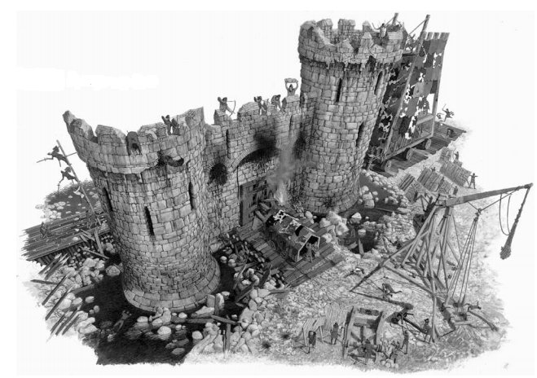
(3 marks)

Word List:
Battlements Trebuchet Gate House Palisades Moat Battering Ram

- Why did Castles eventually become undesirable? (2 marks)

- Explain the difference between Trial by Jury and Trial by Ordeal with the use of examples.
(4 marks)

- Using the European Feudal Pyramid, shown below, list the correct order, the structure of feudal society in medieval times.
(4 marks)

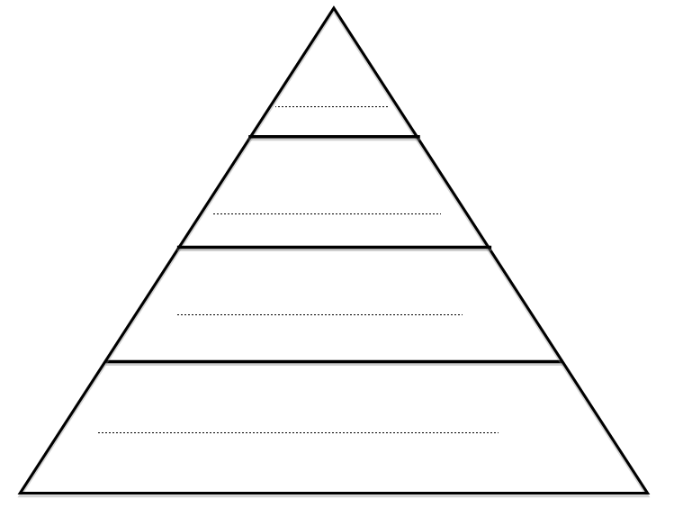

- Look at sources 1 and 2 below and then answer the question below;
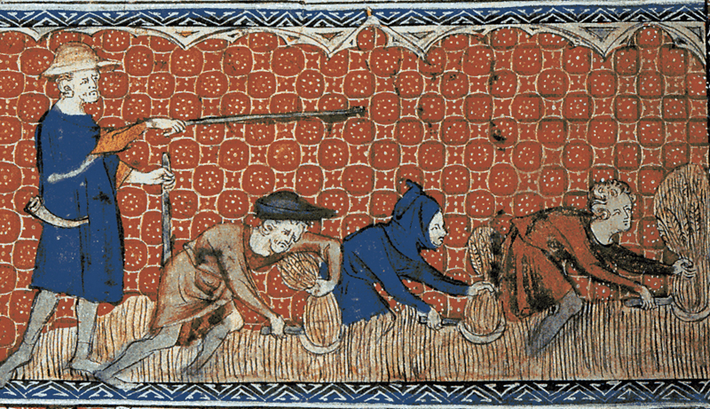
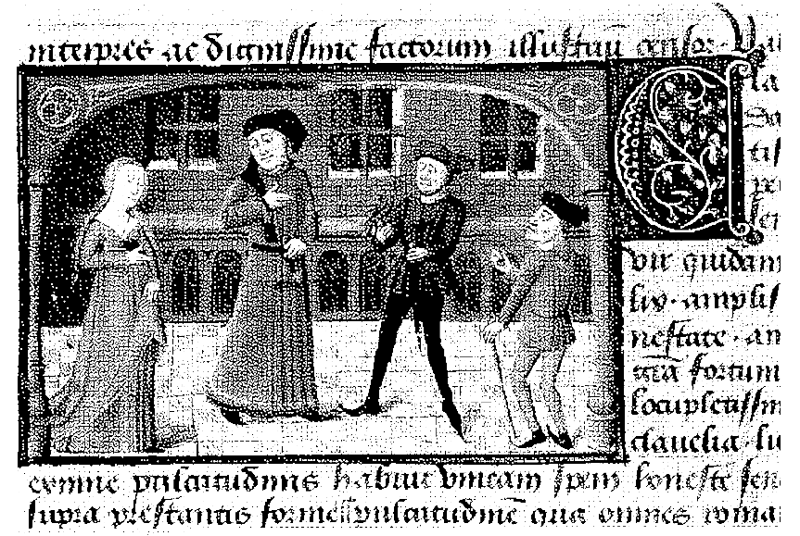
Source 1: Peasants working the land as a Bailiff watches over them.
Source 2: An illustration of a lord and lady in their castle.

Using Source 1 and Source 2 explain how these sources summarise how life was different for peasants and nobles.
(5 marks)

END OF TEST

